**Project: Blue Waters**

**Name: Parveez Ali**

**ID: L30062935**

**CPSC-50900-005 Database systems**

**GitHub URL:**

[**https://github.com/aliparvez12/Bluewaters.git**](https://github.com/aliparvez12/Bluewaters.git)

**Week-1 Assignment**

**Current Date: 11/20/22**

**1.) Identify the specific products that you sell related to the theme above and write a short description of your business that includes what you sell, the size of your organisation, general location, and annual sales goals.**

Blue Waters is a retail sales company that sells underwater-themed action figures from a popular Anime/cartoon aimed at kids. Some of our popular products are Mermaid, Mermaid Princess, and Mermaid Queen.

Blue waters are a small organization with 10 employees. We have 3 locations in the USA, 2 locations in Canada, and 1 location in Mexico. Our annual sales goal is $1,000,000.

We sell our products in stores like Walmart, Target, and Costco.

**2.) Compare your business to a real one by researching the annual sales and number of employees that the real business has.?**

Write the name of the similar business

* Mattel

Write its sales for 2021, and current number of employees.

* 2021 sales: $4.5 billion
* 2021 employees: 30,000

Also provide the URL of where you found the information. This must be from the company website, NOT Wikipedia!

<https://www.mattel.com/en-us>

**3.) Write your description that explains your client server design and what service each tier provides. Even if your network does not use many tiers, identify5 tier function and describe how each would be useful.**

We have 3 tiers in our network. The first tier is the client tier. This tier is where the client interacts with the system. The second tier is the application tier. This tier is where the application is hosted. The third tier is the database tier. This tier is where the data is stored.

The client tier is where the client interacts with the system. The client tier is where the client can view the products and purchase them.

The application tier is where the application is hosted. The application tier is where the application is hosted and where the client can interact with the system.

The database tier is where the data is stored. The database tier is where the data is stored and where the application can access the data.

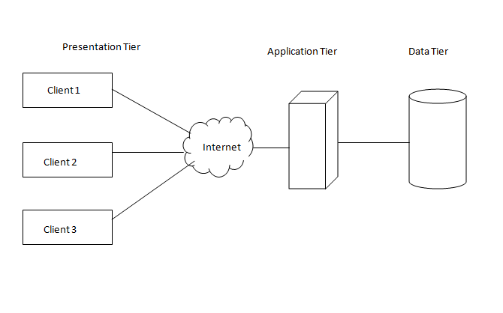

**The 3-tier Architecture**

**Presentation Tier**: The presentation tier is where the client interacts with the system. The presentation tier is where the client can view the products and purchase them.

**Application Tier**: The application tier is where the application is hosted. The application tier is where the application is hosted and where the client can interact with the system.

**Data Tier:** The data tier is where the data is stored. The data tier is where the data is stored and where the application can access the data.

**The 5-tier Architecture**

Presentation Tier: The presentation tier is where the client interacts with the system. The presentation tier is where the client can view the products and purchase them.

Application Tier: The application tier is where the application is hosted. The application tier is where the application is hosted and where the client can interact with the system.

Data Tier: The data tier is where the data is stored. The data tier is where the data is stored and where the application can access the data.

Business Tier: The business tier is where the business logic is stored. The business tier is where the business logic is stored and where the application can access the business logic.

Integration Tier: The integration tier is where the integration logic is stored. The integration tier is where the integration logic is stored and where the application can access the integration logic.

**4.) The business will need to store many different types of data. That means elements of your business related to building and selling your products, not computer data types. Think about 5 important types of data that are related to your business. What do you need to track? List those types in your report.**

The business will need to store many different types of data. The business will need to store the following data: product data, customer data, employee data, sales data, and inventory data.

Product data: The product data is where the product information is stored. The product data is where the product information is stored and where the application can access the product information.

Customer data: The customer data is where the customer information is stored. The customer data is where the customer information is stored and where the application can access the customer information.

Employee data: The employee data is where the employee information is stored. The employee data is where the employee information is stored and where the application can access the employee information.

Sales data: The sales data is where the sales information is stored. The sales data is where the sales information is stored and where the application can access the sales information.

Inventory data: The inventory data is where the inventory information is stored. The inventory data is where the inventory information is stored and where the application can access the inventory information.

**5.) Assume that your business is more than 10-year-old needs to communicate with your new Cloud database setup. The file formats you use to represent business data are incompatible with the Cloud software requirement. Knowing that you need a solution to transfer your data to the new system, please answer the following.**

What kind of tool did we mention in class that performs data translations from one system to another?

Middleware is software that provides common services and capabilities to applications outside of what’s offered by the operating system. Data management, application services, messaging, authentication, and API management are all commonly handled by middleware.

Middleware helps developers build applications more efficiently. It acts like the connective tissue between applications, data, and users.

For organizations with multi-cloud and containerized environments, middleware can make it cost-effective to develop and run applications at scale.

For all the benefits cloud-native development provides, it also brings added complexity. Applications can be deployed across multiple infrastructures, from on-premises systems to public clouds. Architectures can vary widely. Developers are juggling multiple tools, languages, and frameworks. And the pressure is on to do more in less time and at a lower cost.

Organizations turn to middleware to manage this complexity and to keep application development quick and cost-effective. Middleware can support application environments that work smoothly and consistently across a highly distributed platform.

Build here. Deploy there. It works the same, thanks to the middleware beneath the applications.

* Data translation tool
* Data conversion tool
* Data migration tool
* Data transformation tool

Name FIVE current examples of that tool and provide the URL where you found the information.

* Talend - <https://www.talend.com/>
* Informatica - <https://www.informatica.com/>
* Microsoft SQL Server - <https://www.microsoft.com/en-us/sql-server/sql-server-downloads>
* Oracle - <https://www.oracle.com/database/technologies/>
* MySQL - <https://www.mysql.com/>

Name three common data formats that computer systems use to transfer product data between systems.

* XML
* JSON
* CSV